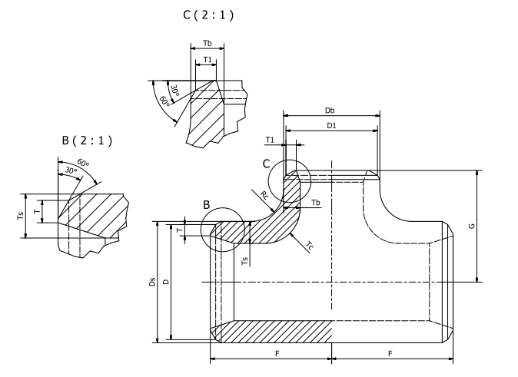

Tablica – Grubości ścianki trójników typu B

 |  |  |  |  |  | 1 |  |  |  | 2 |  |  |  | 3 |  |  |  | 4
DN | D | DN₁ | D₁ | F | G | T | T₁ | T_{s} | T_{b} | T | T₁ | T_{s} | T_{b} | T | T₁ | T_{s} | T_{b} | T | T₁ | T_{s} | T_{b}
15 | 21,3 | 15 | 21,3 | 25 | 25 | 2 | 2 | 4,2 | 3,2 | - | - | - | - | - | - | - | - | - | - | - | -
20 | 26,9 | 20 | 26,9 | 29 | 29 | 2,3 | 2,3 | 4,8 | 3,6 | - | - | - | - | - | - | - | - | - | - | - | -
 |  | 15 | 21,3 | 29 | 29 | 2,3 | 2 | 4,4 | 3,3 | - | - | - | - | - | - | - | - | - | - | - | -
25 | 33,7 | 25 | 33,7 | 38 | 38 | 2,6 | 2,6 | 5,7 | 4,3 | - | - | - | - | - | - | - | - | - | - | - | -
 |  | 20 | 26,9 | 38 | 38 | 2,6 | 2,3 | 5,2 | 3,9 | - | - | - | - | - | - | - | - | - | - | - | -
 |  | 15 | 21,3 | 38 | 38 | 2,6 | 2 | 4,8 | 3,6 | - | - | - | - | - | - | - | - | - | - | - | -
32 | 42,4 | 32 | 42,4 | 48 | 48 | 2,6 | 2,6 | 6,0 | 4,5 | 3,6 | 3,6 | 7,7 | 5,8 | - | - | - | - | - | - | - | -
 |  | 25 | 33,7 | 48 | 48 | 2,6 | 2,6 | 5,5 | 4,1 | - | - | - | - | - | - | - | - | - | - | - | -
 |  | 20 | 26,9 | 48 | 48 | 2,6 | 2,3 | 5,1 | 3,8 | - | - | - | - | - | - | - | - | - | - | - | -
 |  | 15 | 21,3 | 48 | 48 | 2,6 | 2 | 4,8 | 3,6 | - | - | - | - | - | - | - | - | - | - | - | -
40 | 48,3 | 40 | 48,3 | 57 | 57 | 2,6 | 2,6 | 6,3 | 4,7 | 3,6 | 3,6 | 8,0 | 6,0 | 4 | 4 | 8,7 | 6,6 | - | - | - | -
 |  | 32 | 42,4 | 57 | 57 | 2,6 | 2,6 | 6,0 | 4,5 | 3,6 | 3,6 | 7,7 | 5,8 | 4 | 4 | 8,3 | 6,2 | - | - | - | -
 |  | 25 | 33,7 | 57 | 57 | 2,6 | 2,6 | 5,5 | 4,2 | 3,6 | 3,2 | 7,1 | 5,3 | - | - | - | - | - | - | - | -
 |  | 20 | 26,9 | 57 | 57 | 2,6 | 2,3 | 5,2 | 3,9 | - | - | - | - | - | - | - | - | - | - | - | -
 |  | 15 | 21,3 | 57 | 57 | 2,6 | 2 | 4,9 | 3,7 | - | - | - | - | - | - | - | - | - | - | - | -
50 | 60,3 | 50 | 60,3 | 64 | 64 | 2,9 | 2,9 | 6,9 | 5,2 | 3,6 | 3,6 | 8,2 | 6,1 | 4 | 4 | 8,8 | 6,6 | 5,6 | 5,6 | 11,4 | 8,6
 |  | 40 | 48,3 | 64 | 64 | 2,9 | 2,6 | 6,2 | 4,6 | 3,6 | 3,6 | 7,3 | 5,5 | 4 | 4 | 7,9 | 5,9 | 5,6 | 5 | 10,2 | 7,7
 |  | 32 | 42,4 | 64 | 64 | 2,9 | 2,6 | 5,8 | 4,3 | 3,6 | 3,6 | 6,8 | 5,1 | 4 | 4 | 7,4 | 5,5 | - | - | - | -
 |  | 25 | 33,7 | 64 | 64 | 2,9 | 2,6 | 5,1 | 3,8 | 3,6 | 3,2 | 6,0 | 4,5 | - | - | - | - | - | - | - | -
 |  | 20 | 26,9 | 64 | 64 | 2,9 | 2,3 | 4,5 | 3,4 | 3,6 | 2,6 | 5,3 | 4,0 | - | - | - | - | - | - | - | -
65 | 76,1 | 65 | 76,1 | 76 | 76 | 2,9 | 2,9 | 7,2 | 5,4 | 3,6 | 3,6 | 8,4 | 6,3 | 5,6 | 5,6 | 11,8 | 8,9 | 7,1 | 7,1 | 14,4 | 10,8
 |  | 50 | 60,3 | 76 | 70 | 2,9 | 2,9 | 6,3 | 4,8 | 3,6 | 3,6 | 7,4 | 5,6 | 5,6 | 4 | 9,6 | 7,2 | 7,1 | 5,6 | 12,5 | 9,4
 |  | 40 | 48,3 | 76 | 67 | 2,9 | 2,6 | 5,7 | 4,3 | 3,6 | 3,6 | 6,7 | 5,1 | 5,6 | 4 | 9,4 | 7,1 | - | - | - | -
 |  | 32 | 42,4 | 76 | 64 | 2,9 | 2,6 | 5,4 | 4,0 | 3,6 | 3,6 | 6,3 | 4,8 | - | - | - | - | - | - | - | -
 |  | 25 | 33,7 | 76 | 57 | 2,9 | 2,6 | 4,8 | 3,6 | 3,6 | 3,2 | 5,6 | 4,2 | - | - | - | - | - | - | - | -
80 | 88,9 | 80 | 88,9 | 86 | 86 | 3,2 | 3,2 | 7,9 | 6,0 | 4 | 4 | 9,4 | 7,0 | 5,6 | 5,6 | 12,1 | 9,1 | 8 | 8 | 16,5 | 12,4
 |  | 65 | 76,1 | 86 | 83 | 3,2 | 2,9 | 7,3 | 5,5 | 4 | 3,6 | 8,7 | 6,5 | 5,6 | 5,6 | 11,2 | 8,4 | 8 | 7,1 | 14,7 | 11,1
 |  | 50 | 60,3 | 86 | 76 | 3,2 | 2,9 | 6,5 | 4,9 | 4 | 3,6 | 7,7 | 5,8 | 5,6 | 4 | 9,9 | 7,5 | - | - | - | -
 |  | 40 | 48,3 | 86 | 73 | 3,2 | 2,6 | 5,9 | 4,4 | 4 | 3,6 | 7,0 | 5,3 | - | - | - | - | - | - | - | -
 |  | 32 | 42,4 | 86 | 70 | 3,2 | 2,6 | 5,6 | 4,2 | 4 | 3,6 | 6,6 | 5,0 | - | - | - | - | - | - | - | -
100 | 114,3 | 100 | 114,3 | 105 | 105 | 3,6 | 3,6 | 9,0 | 6,8 | 4,5 | 4,5 | 10,7 | 8,0 | 6,3 | 6,3 | 13,9 | 10,4 | - | - | - | -
 |  | 80 | 88,9 | 105 | 98 | 3,6 | 3,2 | 7,9 | 6,0 | 4,5 | 4 | 9,4 | 7,1 | 6,3 | 5,6 | 12,2 | 9,1 | - | - | - | -
 |  | 65 | 76,1 | 105 | 95 | 3,6 | 2,9 | 7,4 | 5,6 | 4,5 | 3,6 | 8,8 | 6,6 | 6,3 | 5,6 | 11,3 | 8,5 | - | - | - | -
 |  | 50 | 60,3 | 105 | 89 | 3,6 | 2,9 | 6,6 | 5,0 | 4,5 | 3,6 | 7,9 | 5,9 | - | - | - | - | - | - | - | -
 |  | 40 | 48,3 | 105 | 86 | 3,6 | 2,6 | 6,1 | 4,6 | 4,5 | 3,6 | 7,2 | 5,4 | - | - | - | - | - | - | - | -
125 | 139,7 | 125 | 139,7 | 124 | 124 | 4 | 4 | 10,2 | 7,6 | 5 | 5 | 12,0 | 9,0 | - | - | - | - | - | - | - | -
 |  | 100 | 114,3 | 124 | 117 | 4 | 3,6 | 9,1 | 6,9 | 5 | 4,5 | 10,8 | 8,1 | - | - | - | - | - | - | - | -
 |  | 80 | 88,9 | 124 | 111 | 4 | 3,2 | 8,1 | 6,1 | 5 | 4 | 9,6 | 7,2 | - | - | - | - | - | - | - | -
 |  | 65 | 76,1 | 124 | 108 | 4 | 2,9 | 7,6 | 5,7 | - | - | - | - | - | - | - | - | - | - | - | -
 |  | 50 | 60,3 | 124 | 105 | 4 | 2,9 | 6,9 | 5,2 | - | - | - | - | - | - | - | - | - | - | - | -

